Project Design Documentation

Project Title & Version Control
Autonomous Cloud SOC: Open-Source Detection & Remediation
Version Control: 2.0 (Self-Hosted/Free Tier Architecture)
Version: DRAFT
Date: 03/11/2026
Change Log: Switched from Azure-native tools to Oracle Cloud (OCI) and Open-Source stack (Wazuh, n8n, Grafana) to ensure $0 operational cost.

2. Project Summary (2–3 sentences)

This project builds a fully functional, automated Security Operations Center (SOC) using open-source tools on Oracle Cloud’s "Always Free" tier. It utilizes Wazuh for log ingestion and SIEM, n8n for security orchestration (SOAR), and Grafana for advanced visualization. The system is designed to detect brute-force attacks on a Windows "Honeypot" and automatically block the malicious IP in the cloud firewall.

3. Problem Statement / Use Case
• The Problem: Small businesses and individual developers face high volumes of automated credential-stuffing attacks. Commercial SIEM/SOAR platforms (like Microsoft Sentinel) often carry high ingestion fees that make 24/7 monitoring cost-prohibitive for smaller projects.
• The Need: A high-performance, $0-cost security pipeline that provides the same enterprise-grade automation (real-time detection and blocking) without the financial overhead of cloud-native security services.

4. Goals and Objectives
• Goal 1: High-Performance Monitoring. Leverage Oracle’s ARM-based instances (24GB RAM) to host a self-managed Wazuh manager capable of processing 100% of telemetry from remote endpoints.
• Goal 2: Infinite Automation. Implement n8n (Community Edition) to handle unlimited remediation workflows (blocking IPs via OCI API) without per-action costs.
• Goal 3: Unified Visualization. Create a Grafana dashboard that aggregates both system performance metrics and global threat intelligence into a single, professional interface.

5. Key Features / Functions
What are the main things your project will do? List the main features you expect the final project to include.

6. Tech Stack and Tools
Component | Technology | Role
Cloud Platform | Oracle Cloud Infrastructure (OCI) | "Always Free" Hosting (A1 Ampere Instance)
SIEM / EDR | Wazuh | Centralized Log Analysis, Rule Detection, and File Integrity Monitoring
SOAR | n8n (Self-Hosted) | Workflow automation to trigger "Deny" rules in OCI via API
Visualization | Grafana | Advanced Geospatial Threat Mapping and Dashboarding
Endpoint | Windows VM | The "Honeypot" target generating security events

7. Architecture / Workflow Diagram
• Ingestion: The Wazuh Agent on the Windows VM monitors Event ID 4625 (Failed Login).
• Analysis: The logs are sent to the Wazuh Manager (OCI). If a specific threshold is hit (e.g., 5 failed logins in 1 minute), Wazuh generates a "High" alert.
• Trigger: Wazuh executes a custom integration script (Python) that sends a JSON payload to an n8n Webhook.
• Enrichment: n8n queries a free Threat Intel API (like AbuseIPDB) to confirm the IP's reputation.
• Remediation: n8n calls the OCI API to add the malicious IP to the "Network Security Group" (NSG) Deny List.
• Reporting: Grafana pulls the incident data from the Wazuh/Indexer database to display the live attack map.

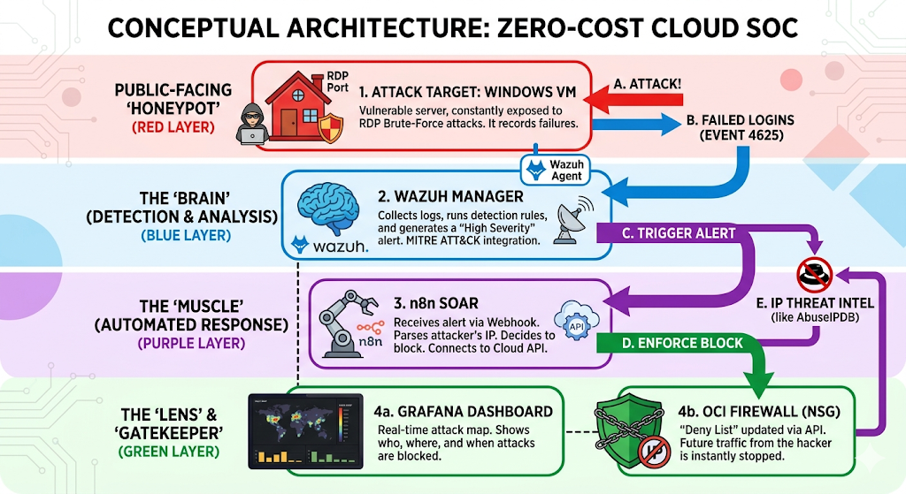

8. Timeline / Weekly Milestones
Phase | Weeks | Focus | Key Outcome
Phase 1: Foundations | 1–3 | Infrastructure Setup | Oracle Cloud VM provisioned; Docker installed; Windows Honeypot live.
Phase 2: Detection | 4–6 | SIEM Deployment | Wazuh Manager active; Agents installed; Brute-force logs visible in dashboard.
Phase 3: Response | 7–9 | SOAR Integration | n8n workflows built; OCI API connected; Successful "Detect-to-Block" test.
Phase 4: Optimization | 10–12 | Visualization & Logic | Grafana map completed; Whitelists tested; Documentation and final bug fixes.

9. Risks and Risk Mitigation
Risk | Mitigation Strategy
Self-Lockout | Hard-code your Public IP as a whitelist "Filter" in n8n to prevent the SOAR from blocking your own access.
Resource Crash | Use the Oracle A1 Ampere (24GB RAM) instance and configure a 4GB Swap File to handle Wazuh’s memory spikes.
Account Reclamation | Keep the Honeypot active to avoid Oracle’s "Idle Instance" deletion policy; export n8n JSONs to GitHub weekly.
Storage Bloat | Set a 14-day retention policy in Wazuh/Indexer to prevent the 200GB disk from filling up with brute-force logs.
Capacity Errors | Provision your Oracle ARM instance immediately, as "Always Free" slots in high-demand regions can be limited.
Integration Failure | Use Docker-Compose to manage Wazuh, n8n, and Grafana, ensuring they share a stable internal network.

10. Evaluation Criteria
• Zero Cost: The monthly billing statement from Oracle Cloud must remain at $0.00.
• Detection Latency: The time from a failed login on the VM to the alert appearing in Wazuh must be under 10 seconds.
• Remediation Loop: The time from alert generation to the IP being blocked in the OCI NSG must be under 30 seconds.

11. Future Considerations
1. Scalability & Maintenance
- Log Lifecycle: Implement automated archiving to low-cost storage to prevent disk saturation as traffic grows.
- Automated Updates: Scripted patching for Wazuh and n8n Docker containers to ensure zero-day protection for the SOC itself.
2. Feature Expansion
- Multi-Vector Detection: Extend rules beyond brute-force to detect lateral movement, MFA fatigue, and privilege escalation.
- Threat Intel Enrichment: Integrate VirusTotal or GreyNoise APIs into n8n to cross-reference IPs against global botnet databases.
3. Advanced Response
- Active Deception: Deploy Canary Tokens or "fake" admin credentials within the VM to identify targeted human attackers vs. automated bots.
- Dynamic Whitelisting: Build a self-service portal for authorized users to temporarily whitelist their IPs via a secure webhook.

